Activity Selection Problem

Problem
We are given n activities with their start and finish times. We have to select the maximum number of activities such that no two selected activities overlap.

Example
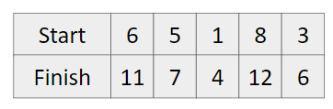
We can select activities in this order
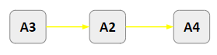
Approach
- Sort all the activities by their finish times
- Greedily select the first activity and jump on the next.
- If the starting time of current activity is greater than the ending time of previously selected activity, then take it otherwise ignore it.

Dry Run
Original start and end times
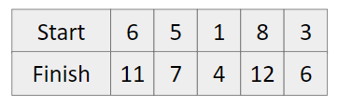

After sorting in increasing order
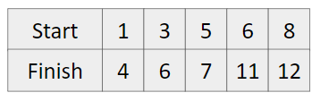
We can select activities in following order
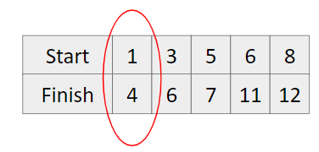
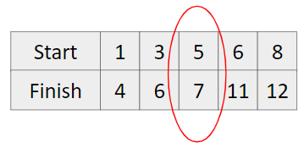
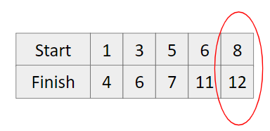

Code
#include<bits/stdc++.h>
using namespace std;
#define int long long

bool compare(pair<int,int> t1, pair<int,int> t2) {
if(t1.second == t2.second) {
t1.first < t2.first;
}

return t1.second < t2.second;
}

signed main() {
int n; cin >> n;

vector<pair<int,int>> times;
for(int i=0; i<n; i++) {
int st, fn;
cin >> st >> fn;

times.push_back({st,fn});
}

sort(times.begin(), times.end(), compare);

int ans = 1;
int previousEndTime = times[0].second;

for(int i=1; i<n; i++) {
if(times[i].first >= previousEndTime) {
ans++;
previousEndTime = times[i].second;
}
}

cout << ans << endl;
return 0;
}

